Latin America Revolutions Graphic Organizer

Zapatistas

Mexico City Independence

Cuban Revolution

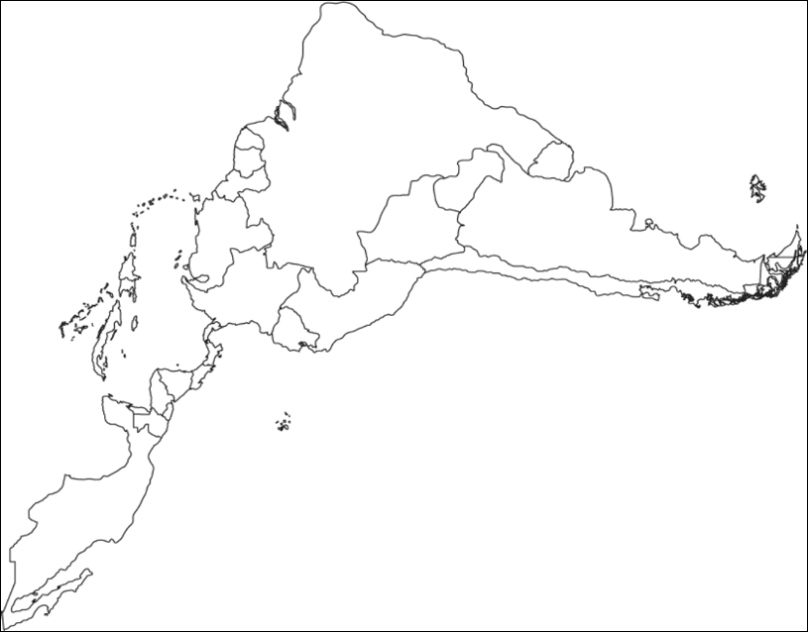

South American Revolutions

Slave Rebellion in Haiti

.